Coffee & Bean

Continuous Assessment 2 (CA-2)

Vinícius Araújo dos Santos – 23409622

Danielle Caroline da S. Medeiros – 23385731

Deysemare Menezes Santos -23157607

HDCSDEV_INT - Web Design and Client Side Scripting

Higher Diploma in Science in Computing

**29 November 2024**

Eugene McLaughlin

**Index**

Introduction 3

A situation where a database is used to manage and record daily transactions. 4

Conceptual Design 5

1. Relational Design 5

2. ER diagram 5

3. Explanation 6

Questions 7

1. Create the corresponding database. 7

2. Create all the necessary tables identified. 7

3. Populate at least three of your tables with some data. 9

4. Populate your database with a large data set representing a one-year transaction. 10

5. Update a column in a table of your choice. 10

6. Delete a column in a table of your choice. 11

7. Show the total number of transactions your database is storing and customer with the highest number of purchases. 11

8. Write a query statement that includes “Order by” and “Group by”. 13

9. Write a query statement that uses pattern matching. 14

10. Show information from three tables based on criteria of your choice. 14

11. Create a view that includes information from the most frequent seven transactions. 15

12. Create a set of queries that summarizes the annual transactions: 17

# 1.Project Summary

As lovers of coffee and its flavours, the Coffee Shop theme will be demonstrated within the website, where it is possible to delve into the history of coffee planting, harvesting on farms or the entire journey that this bean takes until it reaches our cups to give us energy or take a break during the day. We offer an intuitive, easy-to-navigate website, where customers can find information on coffee package prices, location, opening hours, which improves their overall experience of the café. According to the website <https://brewsmartly.com/most-coffee-obsessed-cities/>

Dublin is the second most coffee-obsessed capital in Europe behind Amsterdam, with an estimated 2 billion cups of coffee served every day, there are 181 coffee shops per 100,000 people making the search for a brew effortless.

# 2.Design Process

# 2.1. Presenting of data

Before developing the website, a survey was carried out on coffee planting in Latin America, and some searches for coffee shop websites were analysed as a model and idea for the creation of Coffee Bean, always aiming for the quality of the coffee beans and concern for the producers when planting. Below are some images of the model websites.

Fig.1 Cool Hand Coffee Roasters from <https://coolhandcoffeeroasters.ie>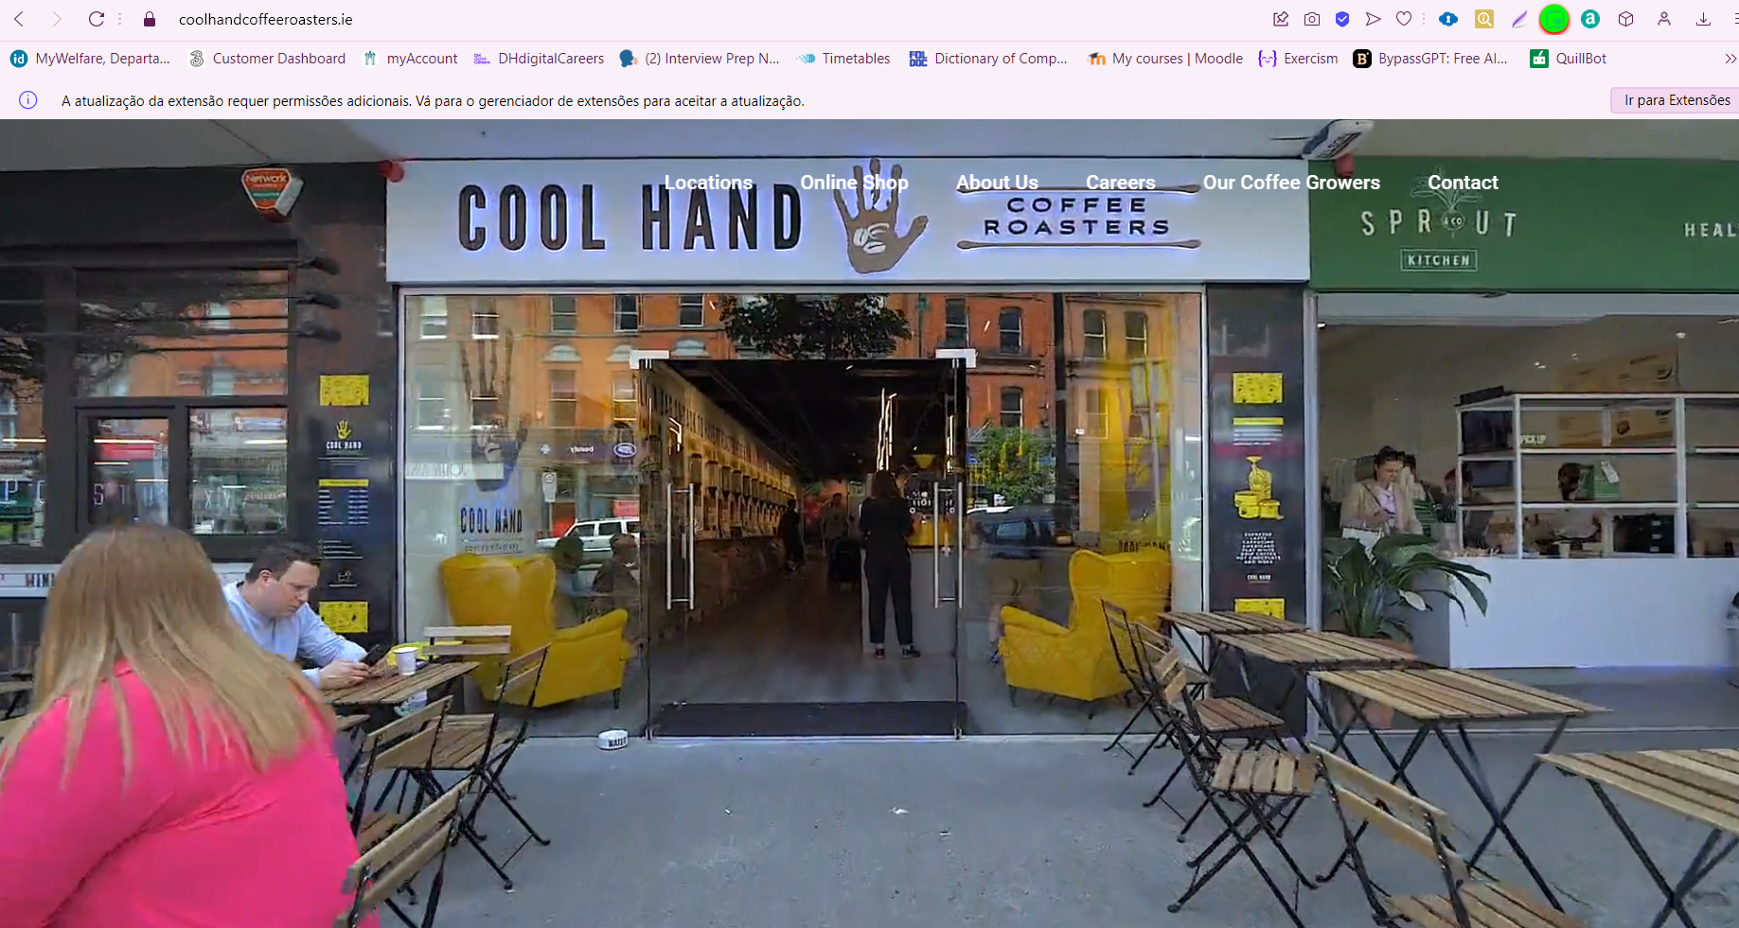

Fig.2 Coffee Shop Kaph from <https://kaph.ie>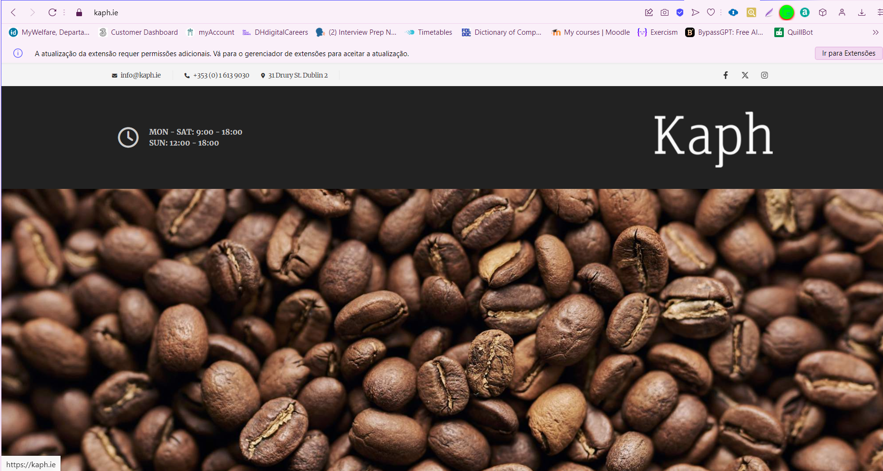

# 2.2. Specifications and Technical Strategy

The requirements assessment showed that in order to develop a website for a coffee shop, it would be necessary to understand the customer's needs, i.e. what types of beans are used, how the roasting is carried out, where the beans come from, what the processes are before they reach the shop until they are served to the customer, after a market study the prices for the coffee packets could be determined according to the law of supply and demand and all costs provided for.

# 2.3 Layout e Wireframe

# 2.3.1 Layout

With the aim of achieving importance and establishing an innovative, intimate and sophisticated yet conservative website, the colours of coffee were used, with some images having a greener tone due to the coffee plantation and brown to highlight the coffee bean after roasting. the colour white was chosen for the letters of the ‘navbar’ due to the brown background, while the letters of the body of the page follow a black pattern in the body against the white background, making it easier to read and navigate the site.

When browsing the website, you'll notice a pattern on all the pages for the ‘navbar’ = top of the website, where the page navigation is located, and the ‘footer’ = foot wheel at the bottom of the page, associated with the social media ‘facebook’ and ‘instagram’.

Fig.3 ‘navbar’, the standard menu for all pages.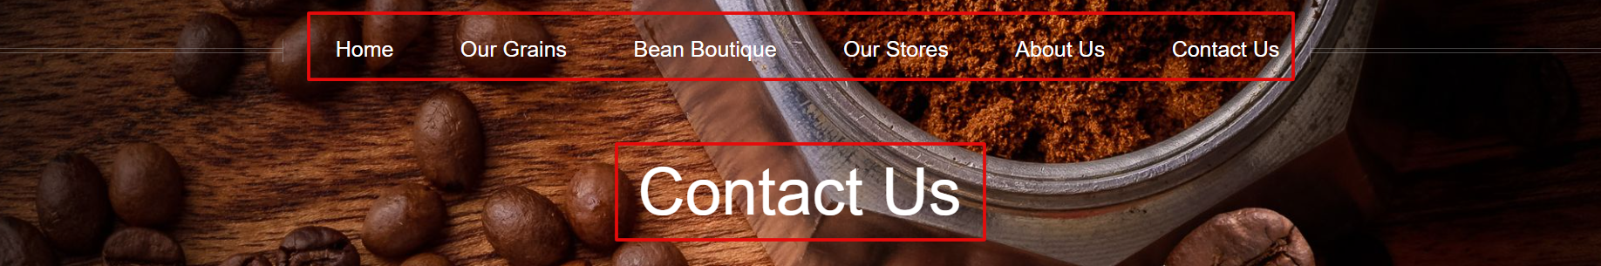

Fig. 4 ‘Footer will turn 6 pages.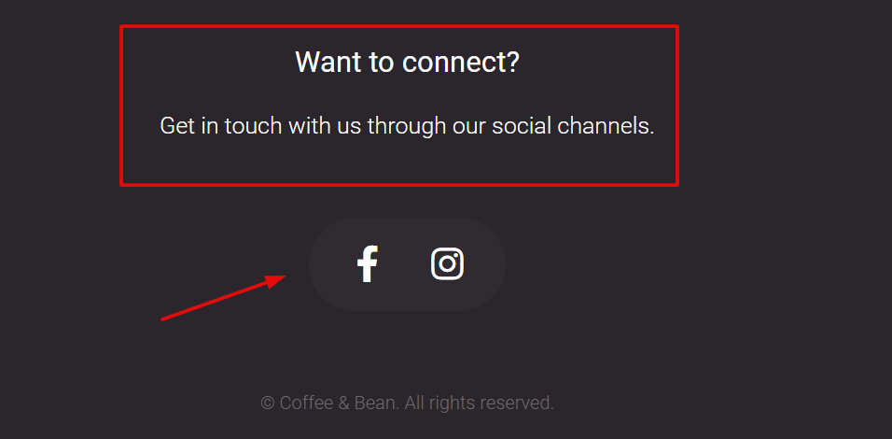

2.3.2 Wireframe

Fig 5. Our Store page (create by Danielle Medeiros)

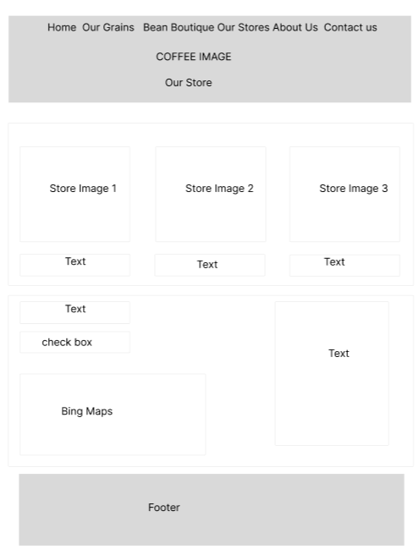

Fig 6. About us page (create by Danielle Medeiros)

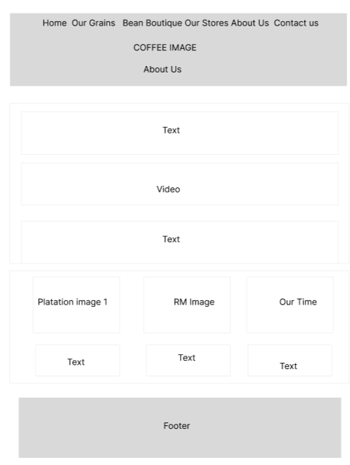

Fig 7. Our Grains page (create by Vinicius Araujo)

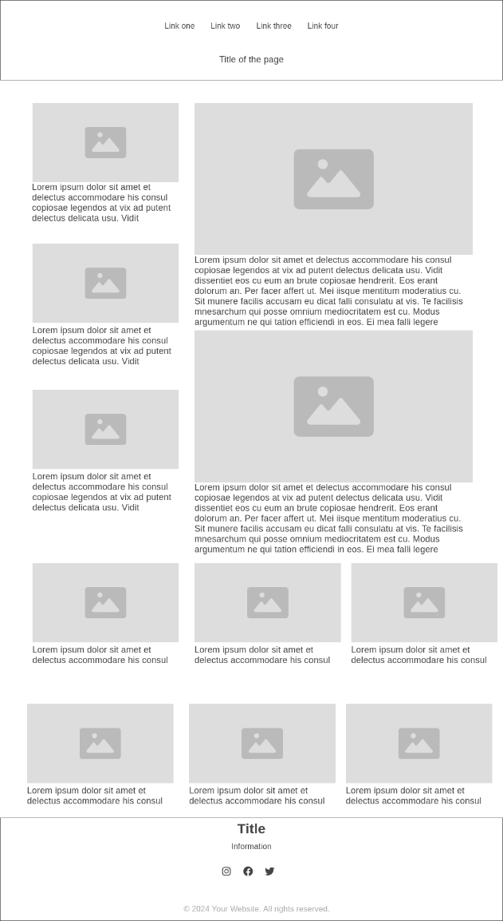

Fig 8. Bean Boutique page (create by Vinicius Araujo)

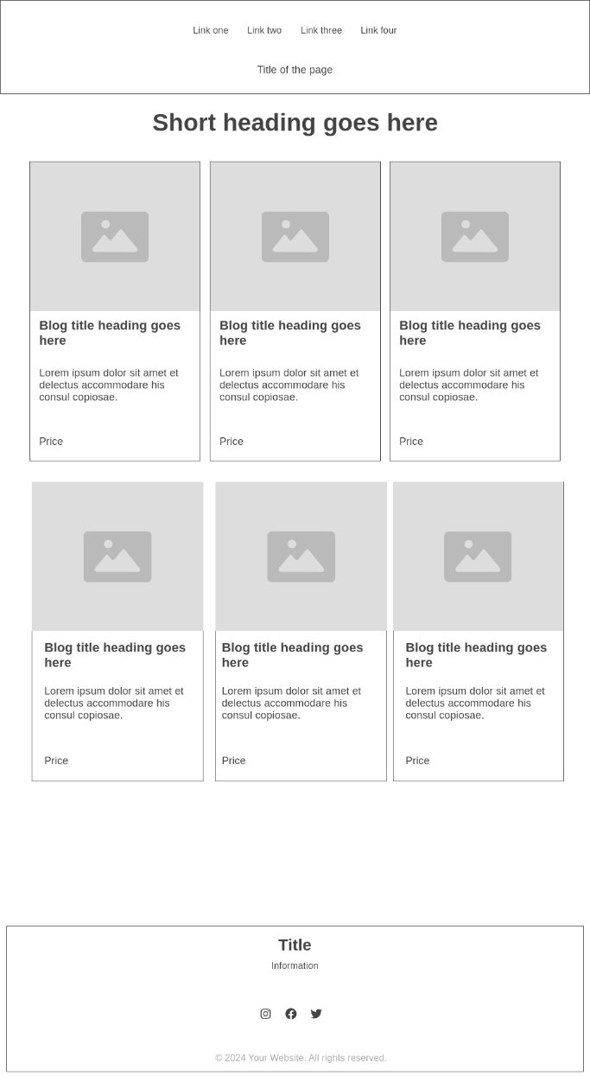

Fig 9. Home page (create by Deyse)

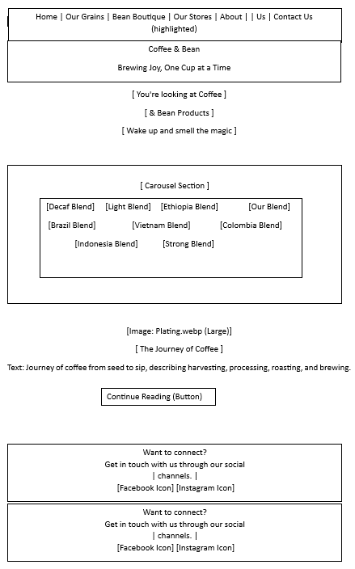

Fig 10. Contact Us (create by Deyse)

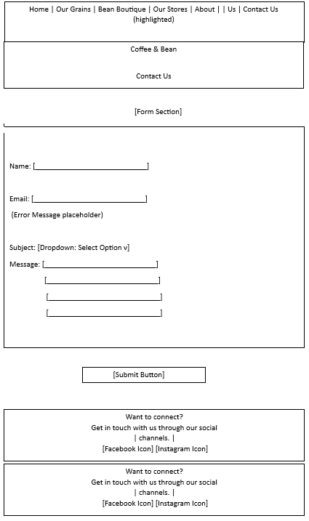

# 3. Collaborative effort

# 3.1. Task Dissection

Deyse: developed the index and contatcUs page. The index page has the purpose to introduce the brand, showcase its offerings, and provide a gateway to other sections of the site. The layout and structure of the pages were based on the required features (e.g., contact form, carousel, content sections). HTML provides the foundation for this structure. The visual elements were crafted using CSS, either written externally or imported from libraries like Font Awesome. A consistent colour scheme and typography were likely used to reflect the Coffee & Bean branding. JavaScript scripts, were combined with libraries like jQuery, used to add interactivity and functionality to elements like the form and carousel. It was insured responsiveness using meta tags and frameworks like Breakpoints.js. Debugging tools and browser developer tools were likely used to test the code for compatibility and functionality.

Danielle: Responsible for creating the About Us and Our Stores pages, developing the Bing map integration in javascript and the display of opening times and statuses, creating the CSS file, including the classes

Vinicius: Responsible for creating the Bean Boutique and Our Grains pages.

# 4.Development

4.1.Bootstrap:

Bootstrap provides a solid, responsive foundation, speeding up the development process and guaranteeing a consistent design, which brings a number of benefits to the website: Increased productivity when using ready-made components.

Guaranteed responsiveness for mobile devices, cross-browser compatibility, Ease of learning to build modern interfaces.

In order to quickly and uniformly deliver responsive layout features and stylized components, Bootstrap has been used.

Fig 12. More responsive images for mobile use. About US page.

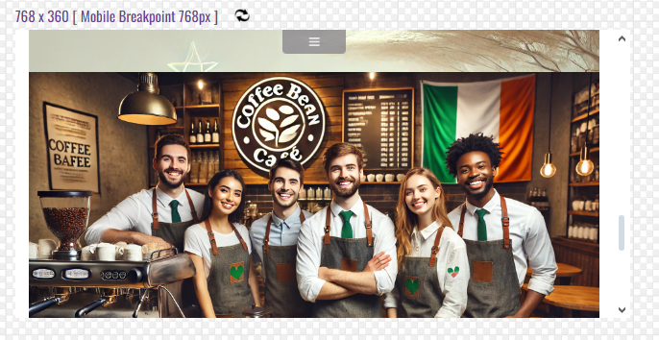  
Fig 13. we can observe greater responsiveness when it comes to bringing two images in the same block. Our Grains page.

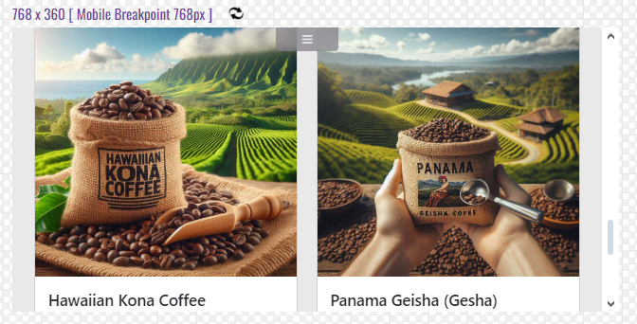

4.2. jQuery:

As you already know, jQuery is used to link elements in HTML and is one of the most popular libraries used. we apply responsiveness to the pages, meaning that if accessed from another platform, the quality of the visualisation is not lost, especially in the menu, which needs to be visible if the website is accessed via mobile phone.

Fig 14. Our Stores As the page is reduced in size, the quality of the menu and the visualisation of the content is not lost.  
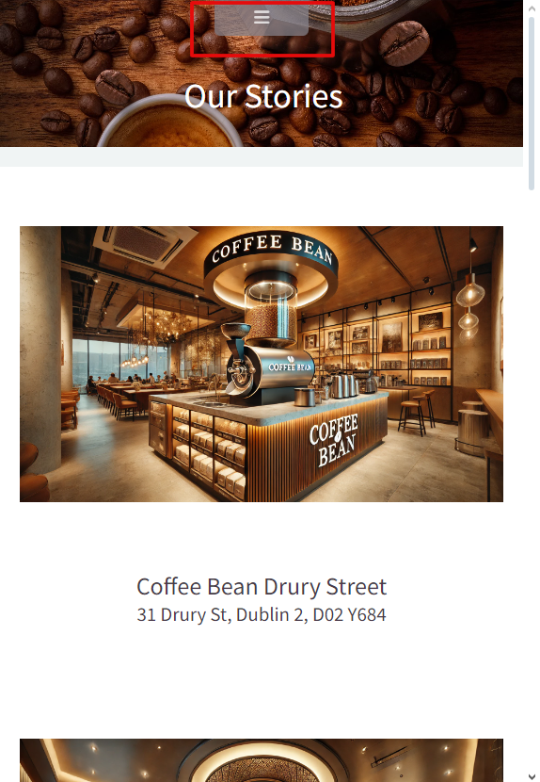

4.3. Validation

The website was validated before it was uploaded.

Fig 15. About Us Html Validation

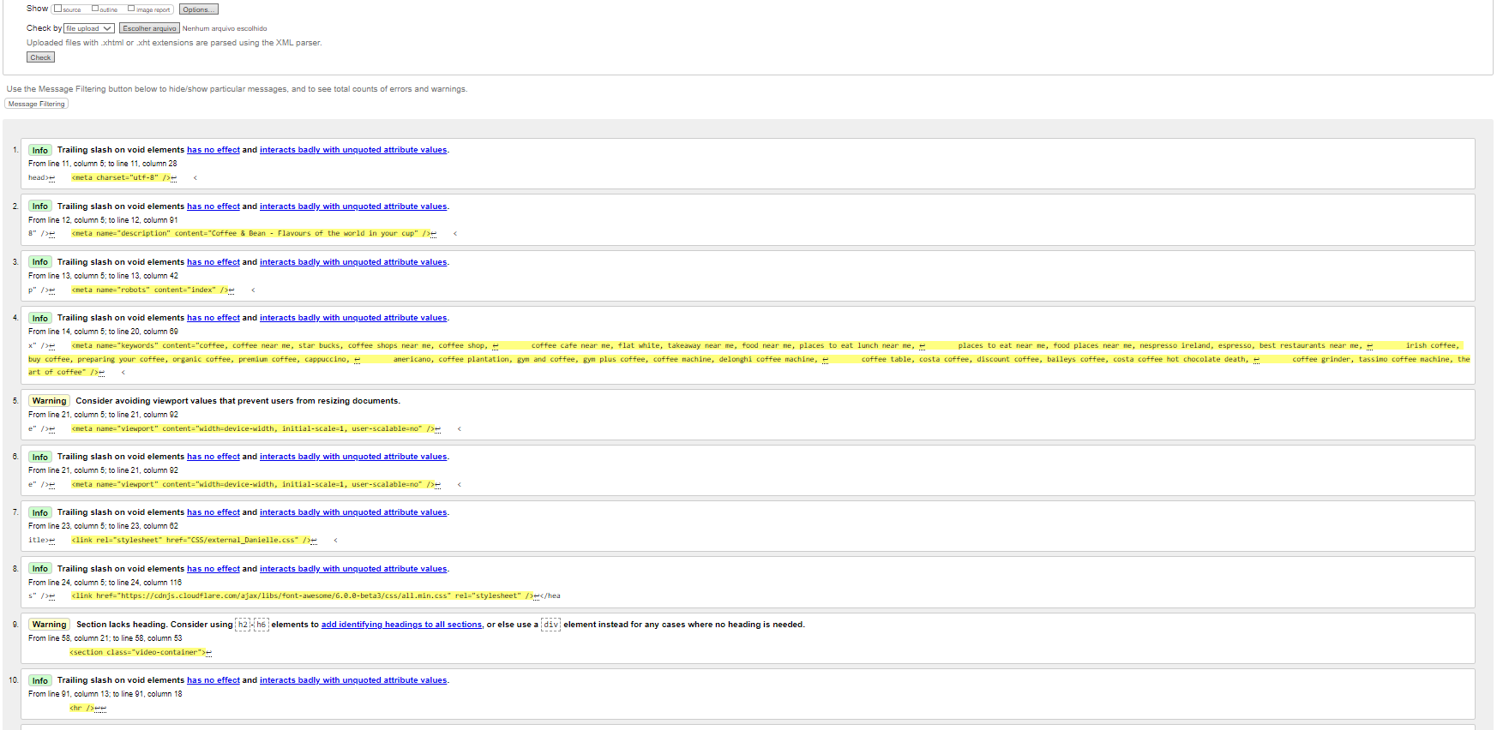

Fig 15.1.About US Html Validation an error found in the footer section.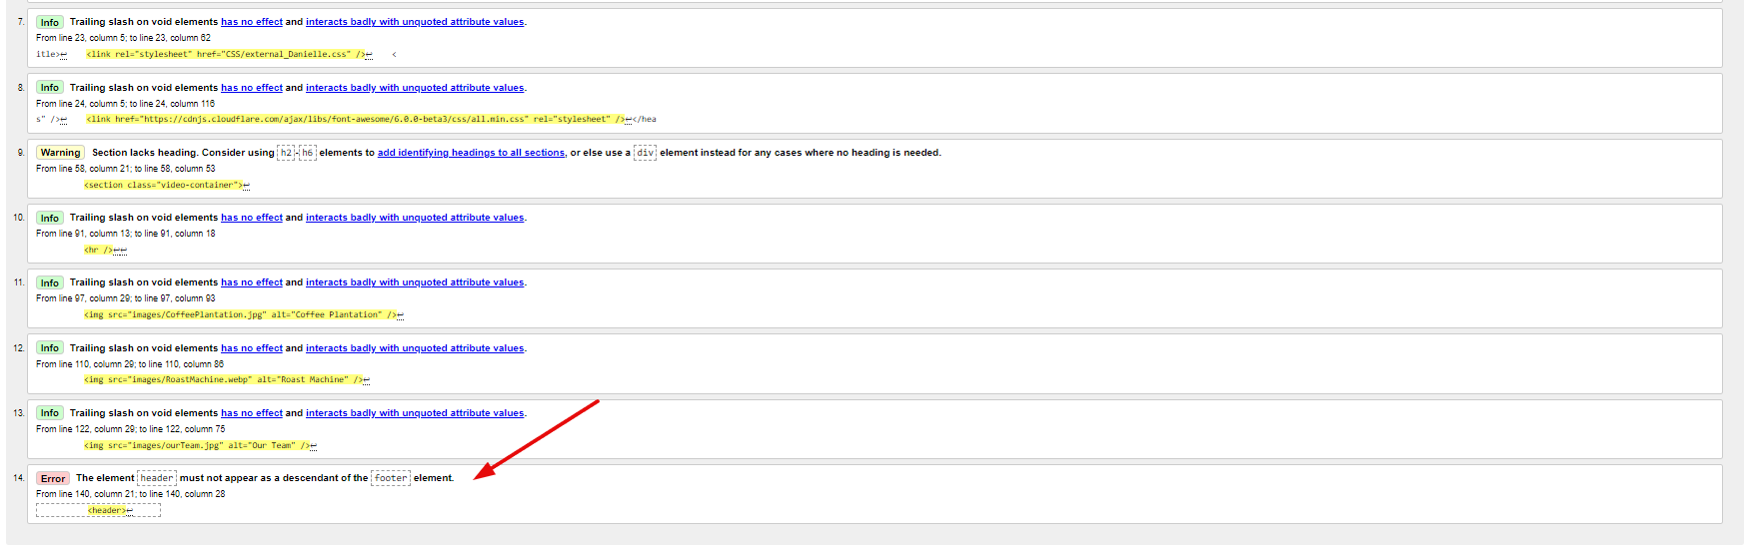

Fig 16. Our Store Html page.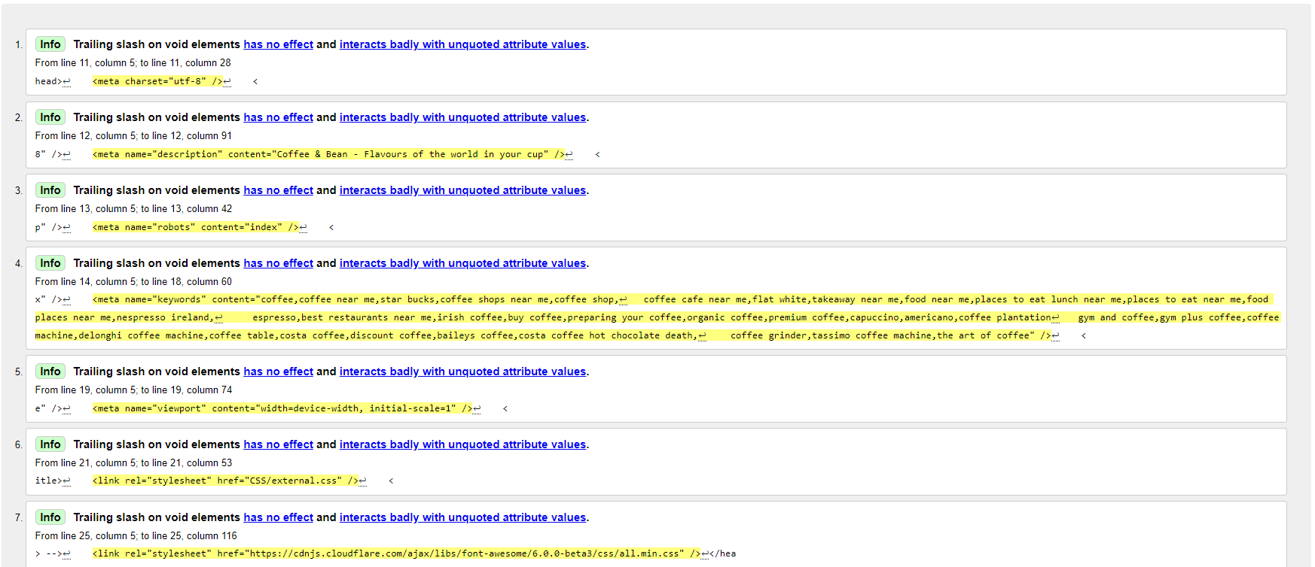

Fig 16.1. Our Store Html an error found in the footer section.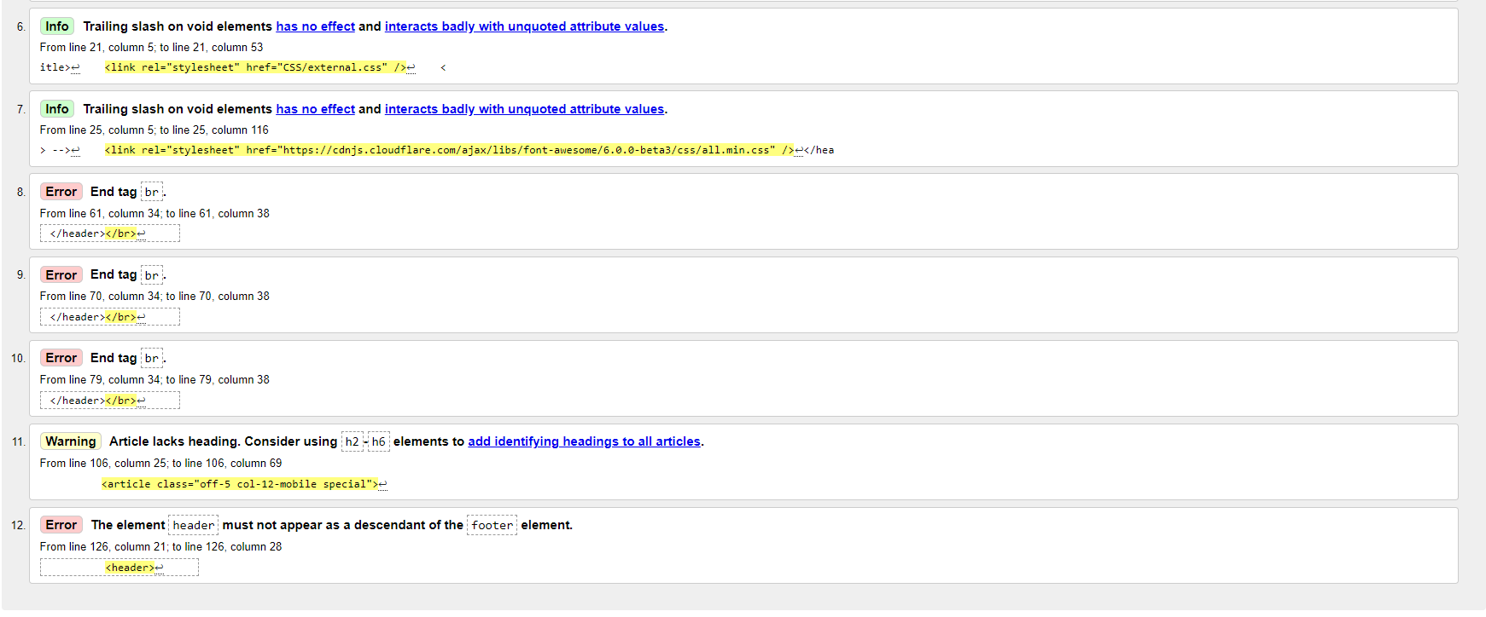

Fig 17. Bean Boutique.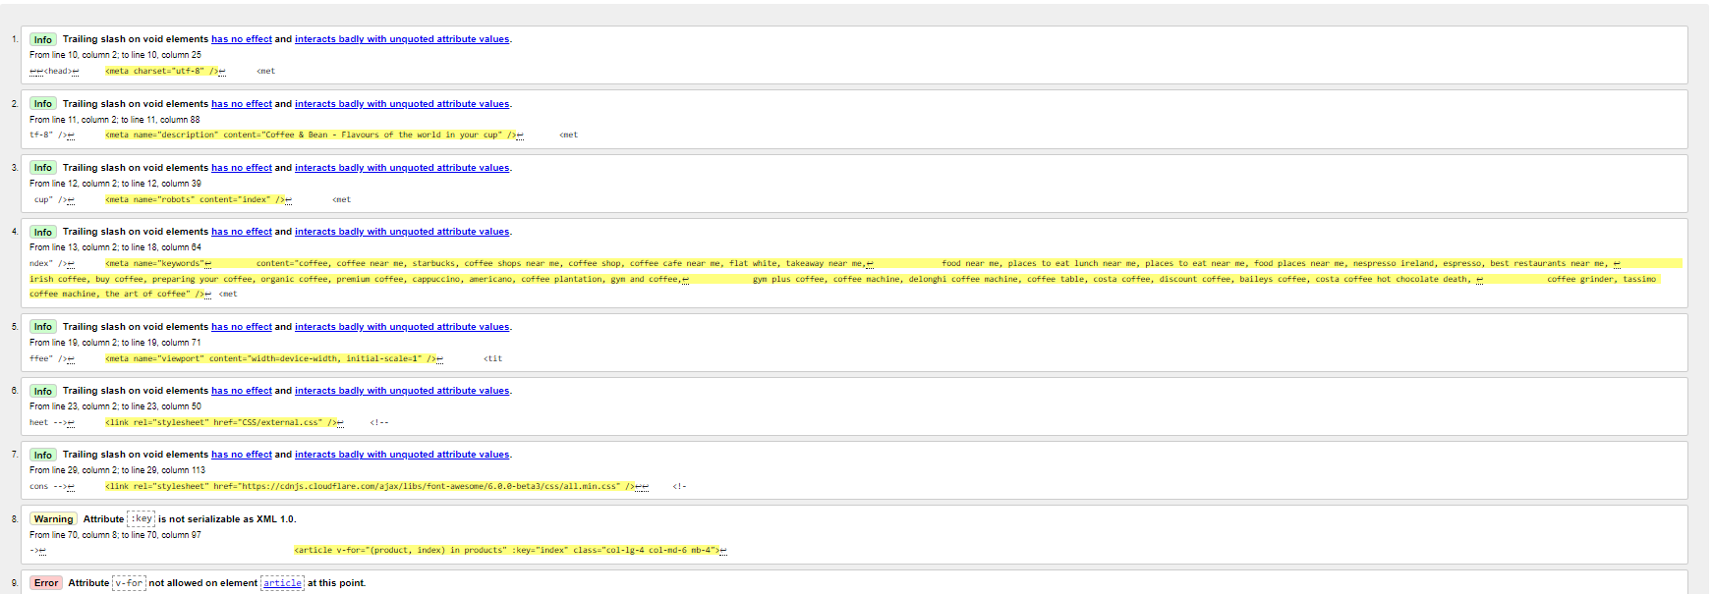

Fig 17.1 Bean Boutique.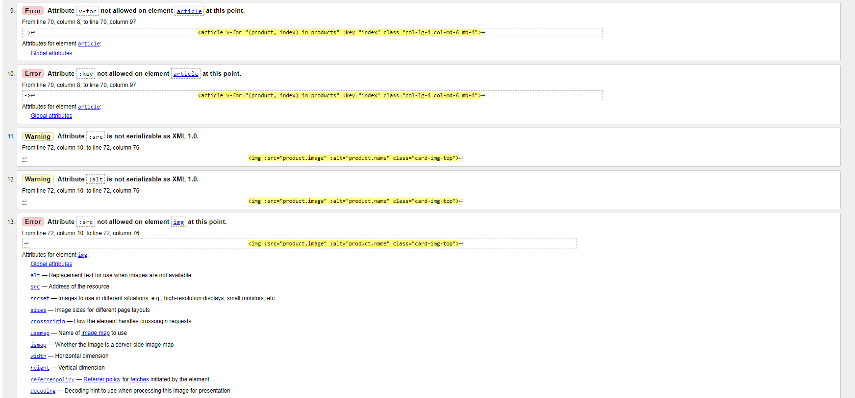

Fig 17.2 Bean Boutique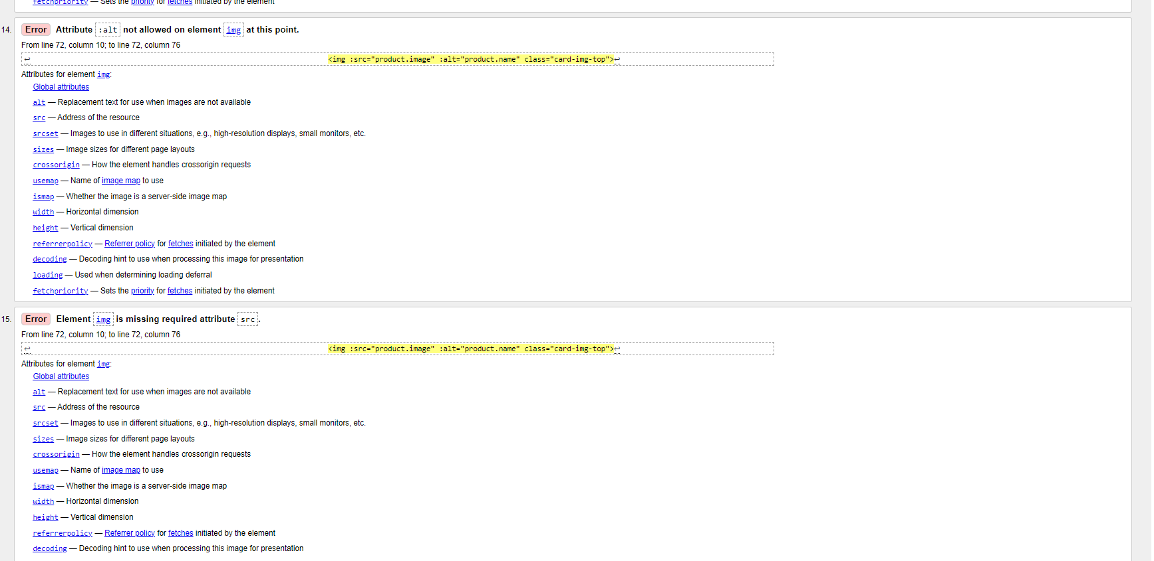

Fig 17.3 Bean Boutique.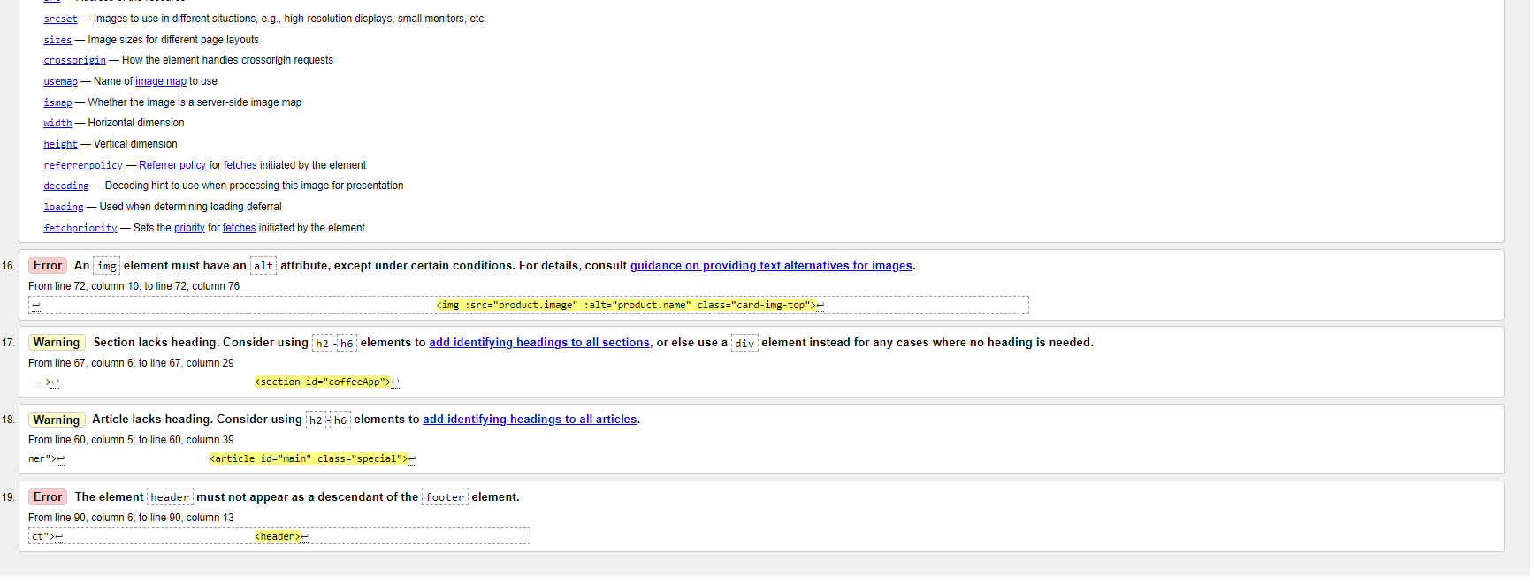

Fig 18. Our Grains.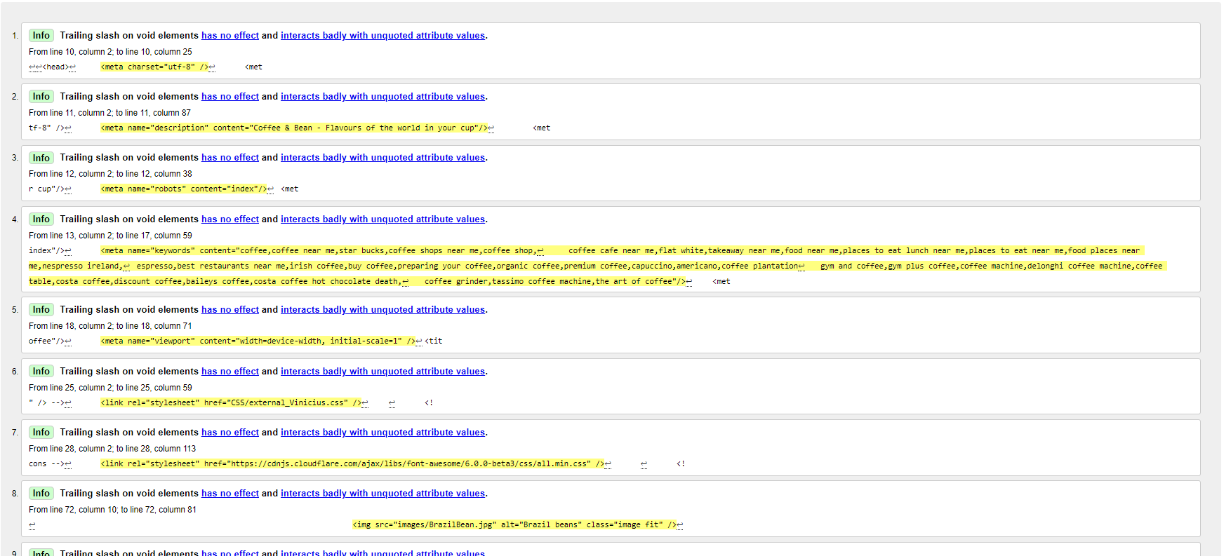

Fig 18.1 Our Grains.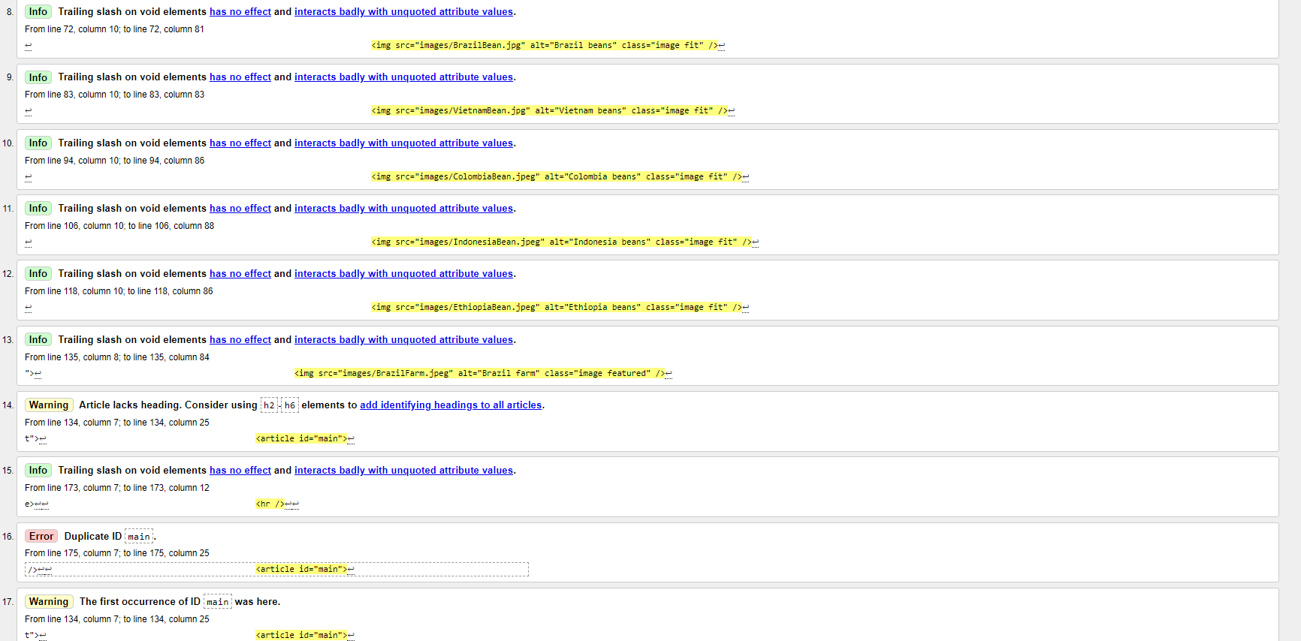

Fig 18.2 Our Grains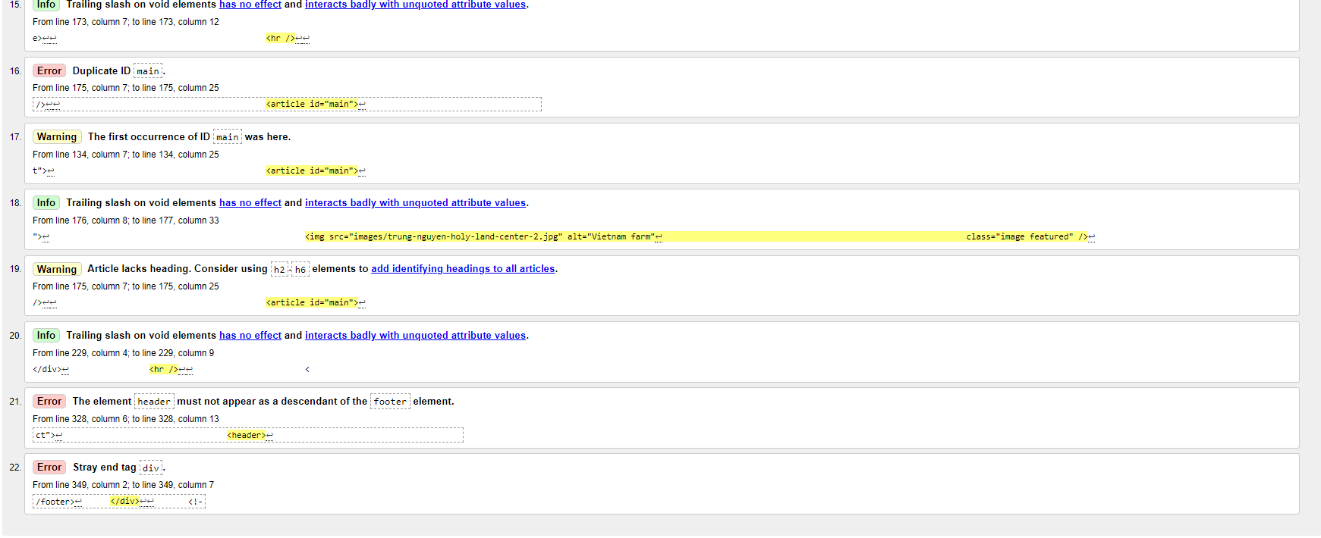

Fig 19. Contact Us Html Page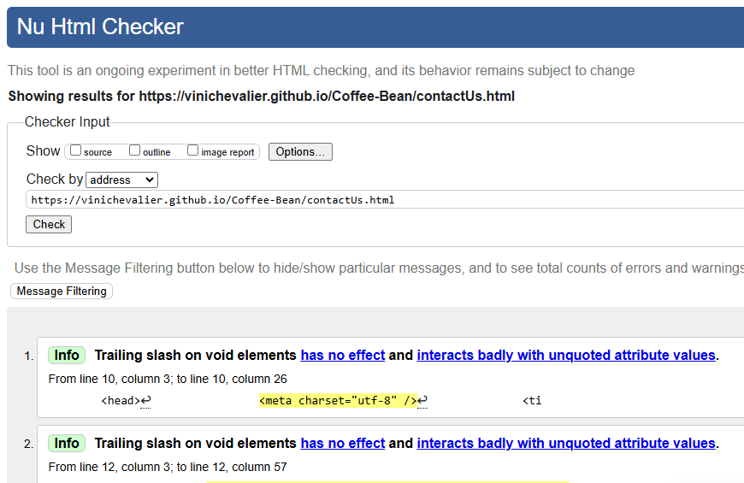

Fig 20. Home(index) Page Html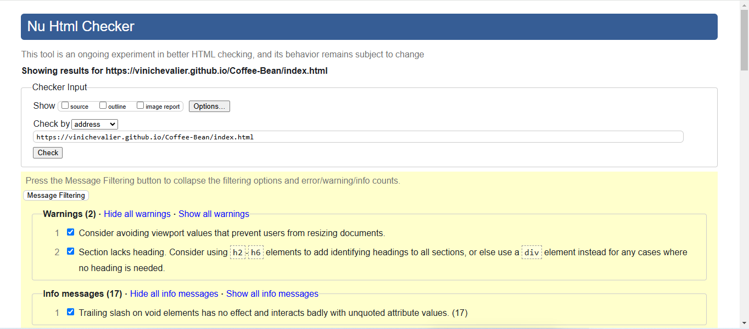

4.3.1 C ss Page Validation on

Fig 21. Deyse_css 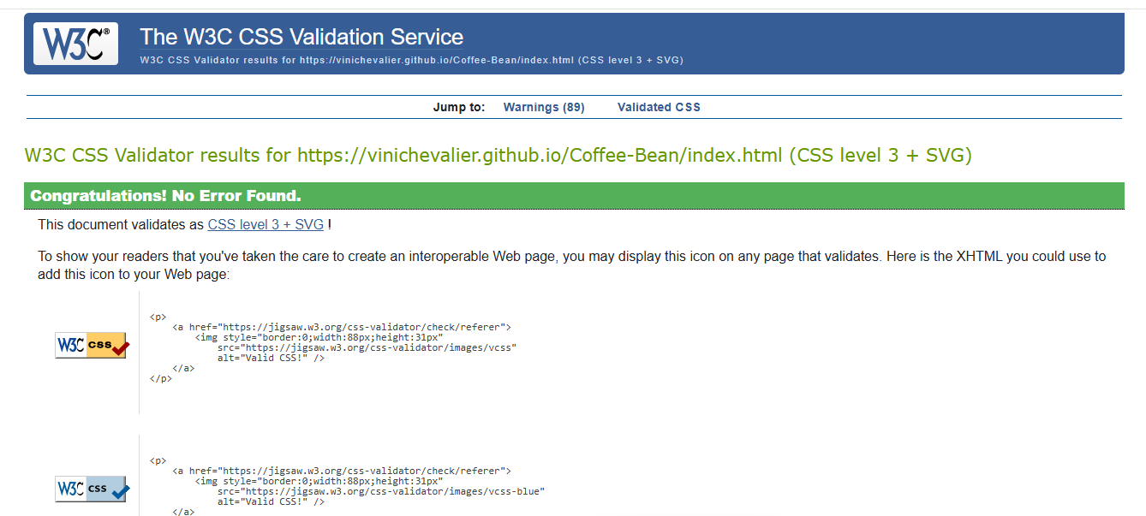

Fig 22. Danielle_css.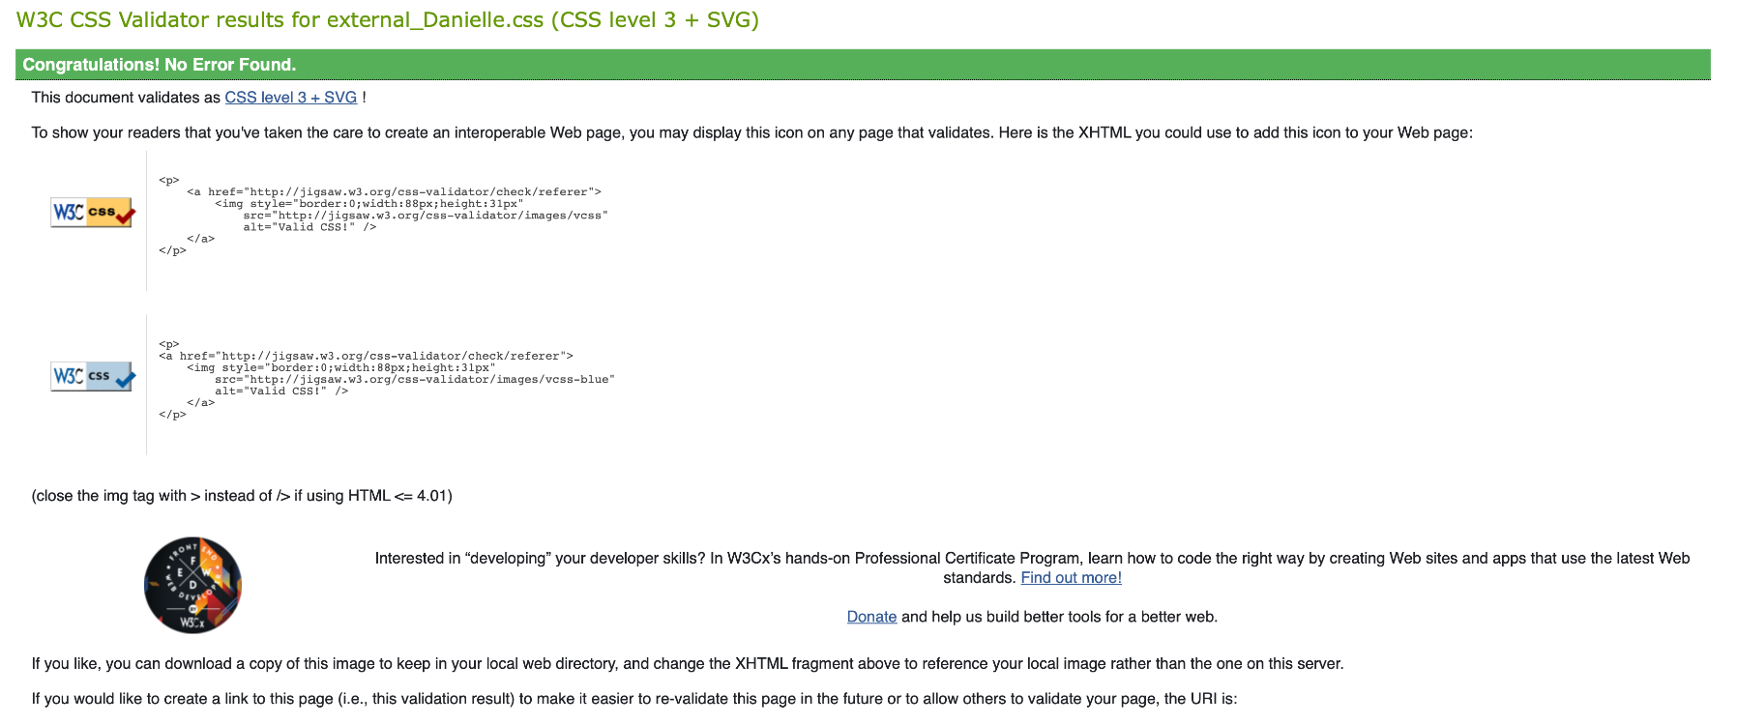

Fig 23. Vinicius_css.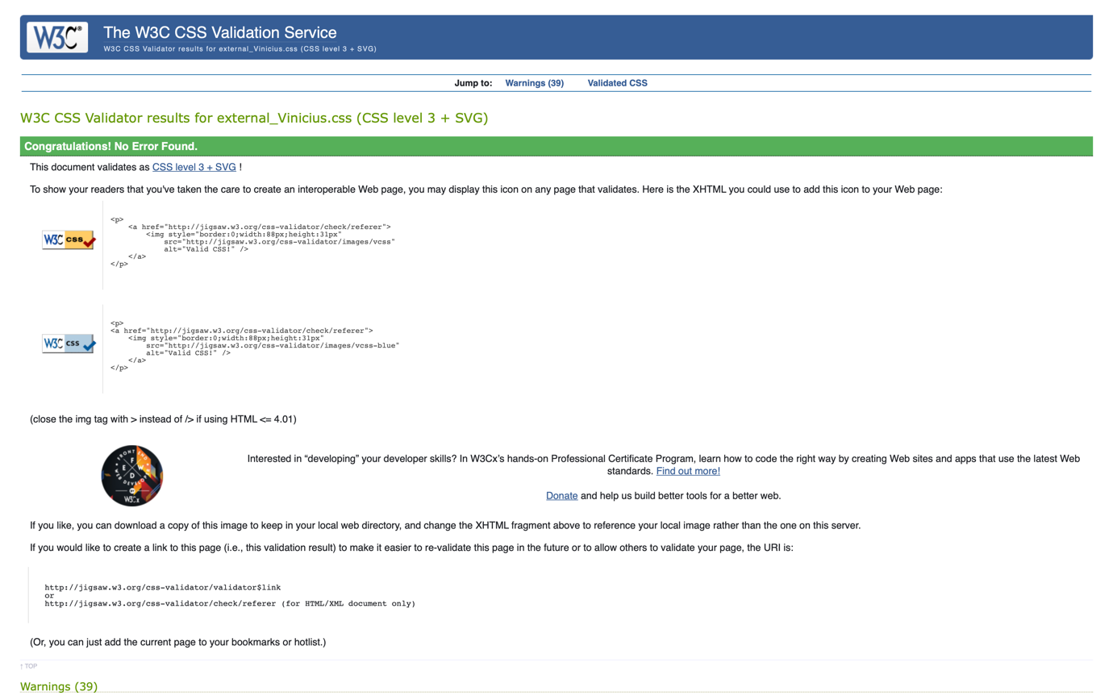

Fig 24. External_css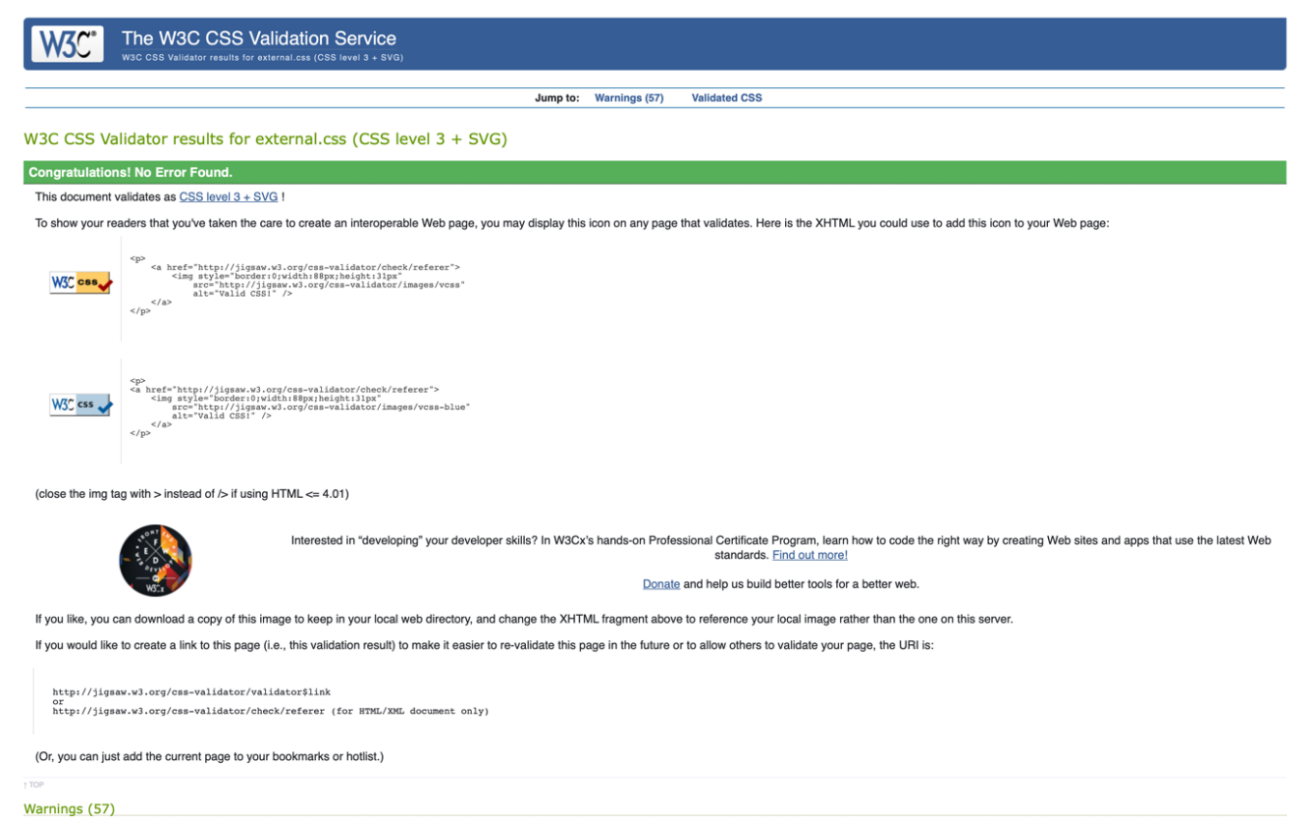

4.4. Responsive Validation Mobile

Offering more quality to the website, responsiveness can be visualised in the texts and images inside the tags.

Fig 25. About Us page. 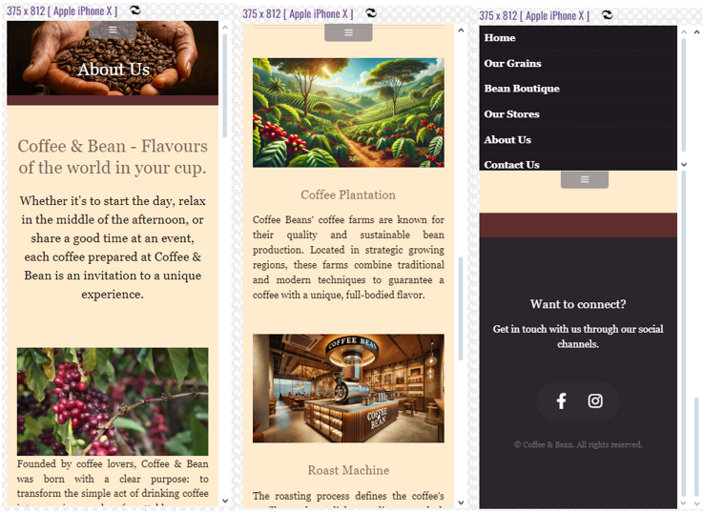

Fig 26. Our Store.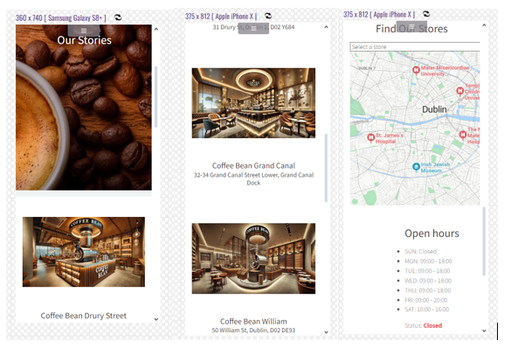

Fig 27. Home Page.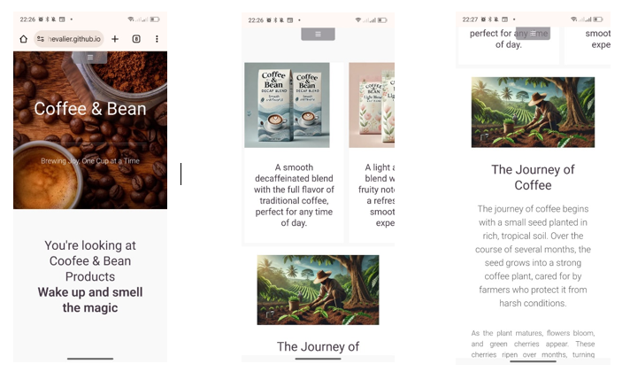

Fig 28. Contact Us.

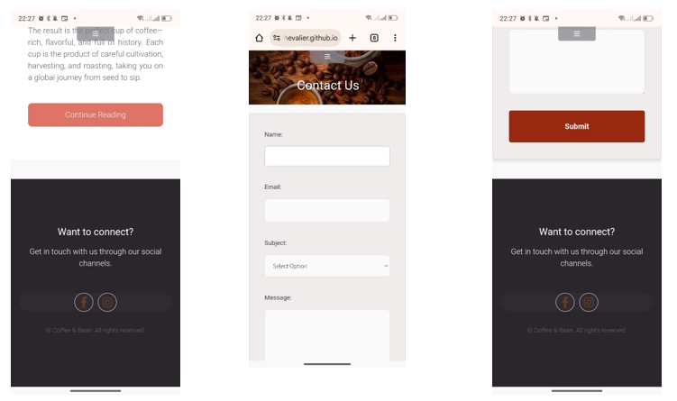

Fig 29. Our Grains.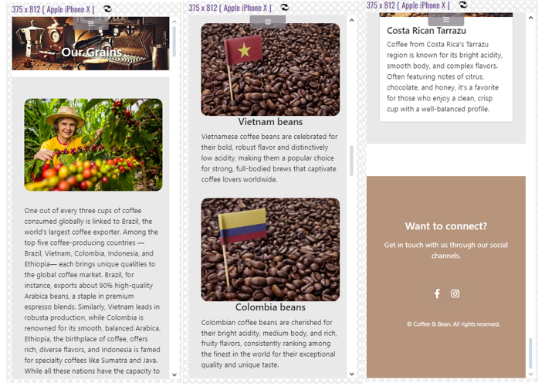

Fig 30. Bean Boutique.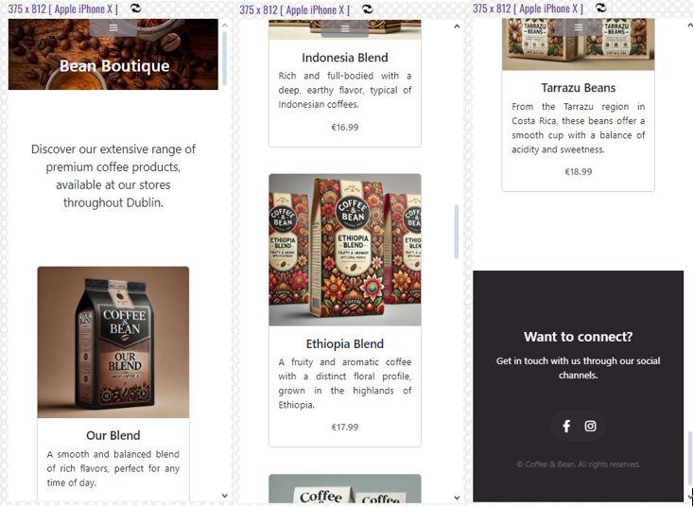

4.5 Responsive validation Desktop.

Fig 31. validation performed Our Stories on Desktop 1024x768.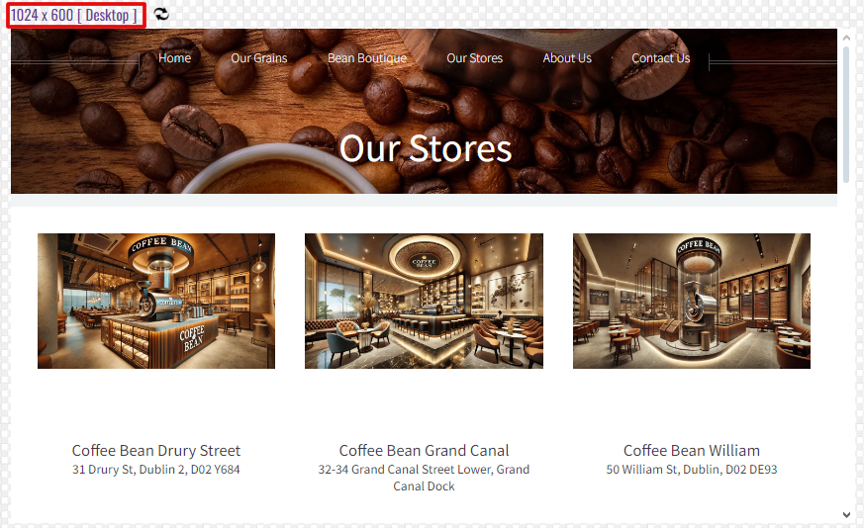

Fig 32. validation performed About Us on Destktop 1024x768. 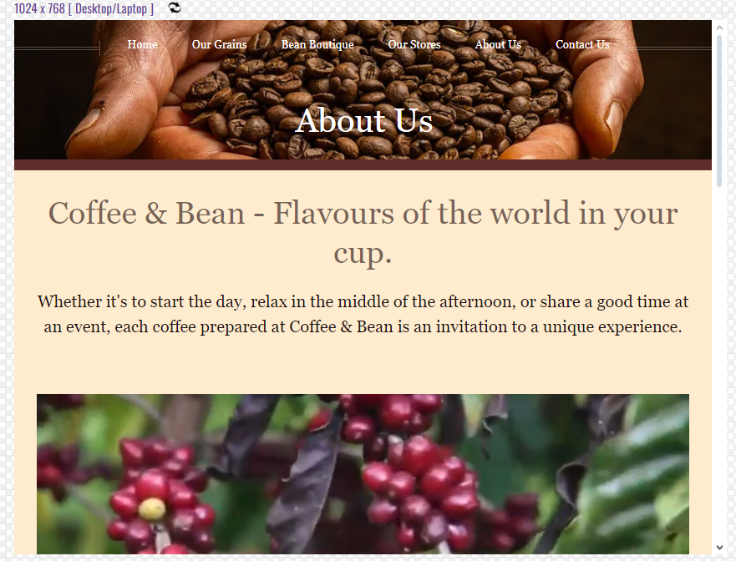

Fig 33. Microsoft Edge(browser) Contact US on Destktop .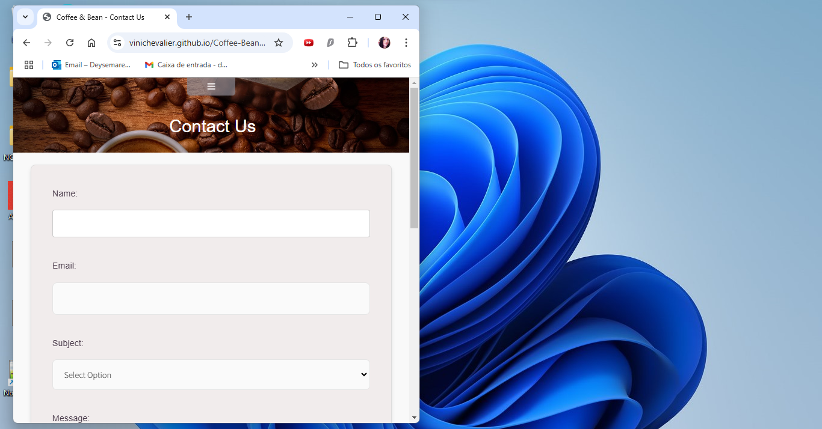

Fig 34. Microsoft Edge(browser) Home Page on Destktop 1024x768.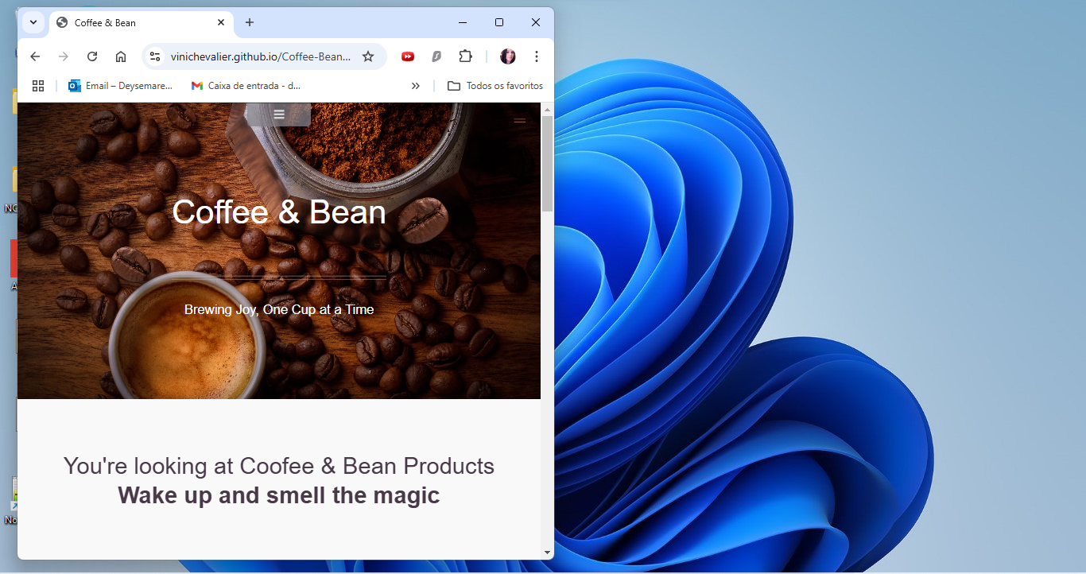

Fig 38. Google Chrome carousel Home page validation.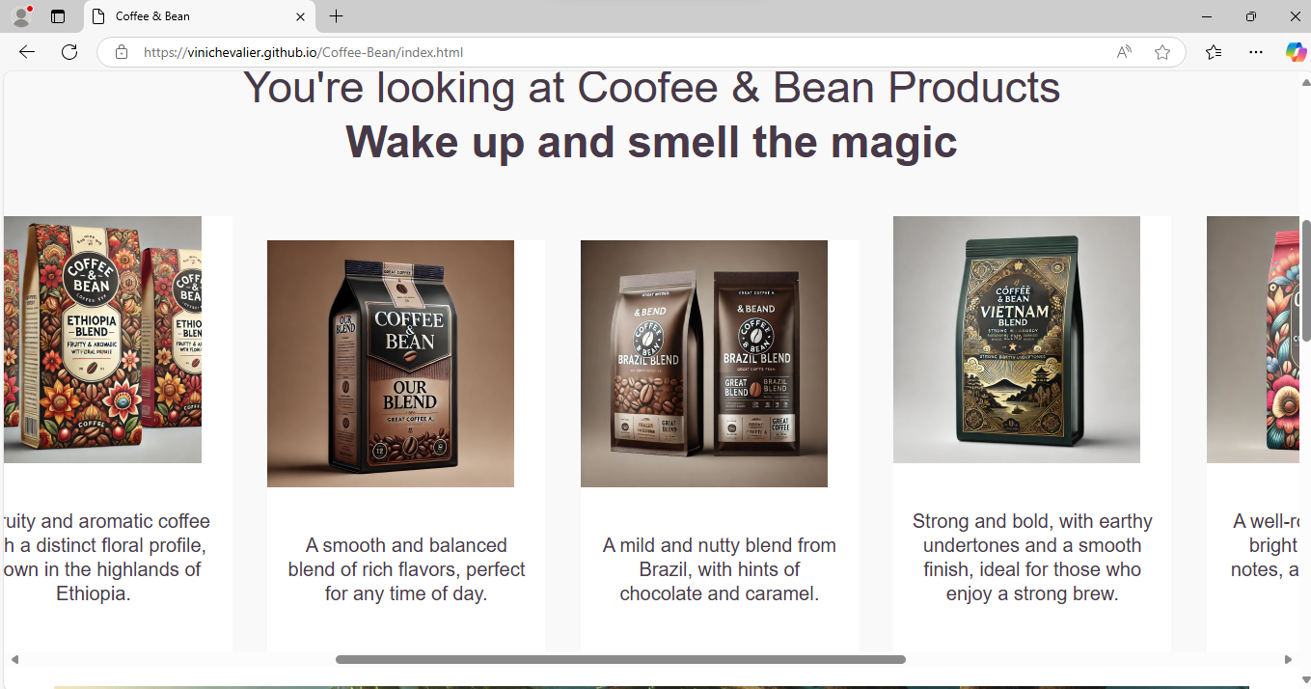

Fig 36. Google Chrome carousel validation.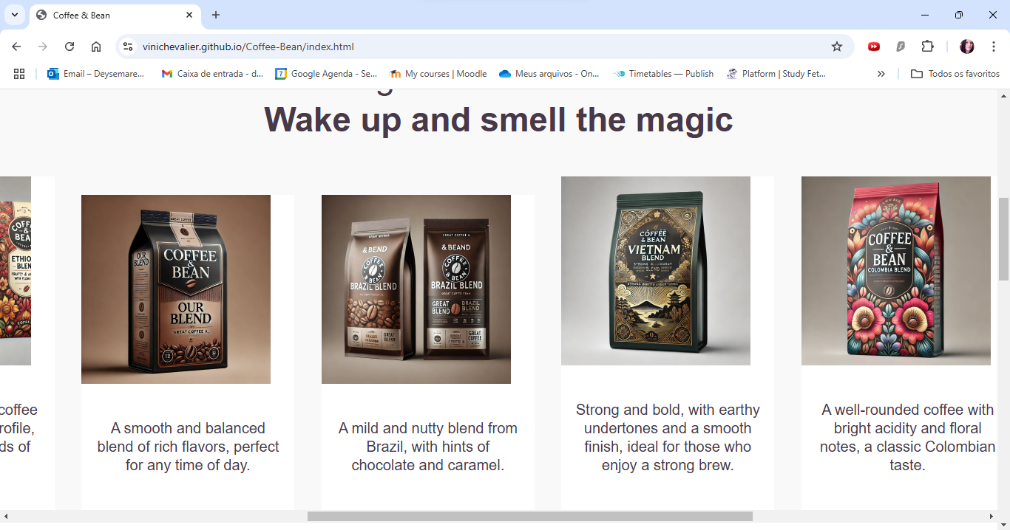

Fig 37. Bean Boutique desktop.

Fig 38. Our Grains desktop.

Fig 39. Our Grains speed Validation.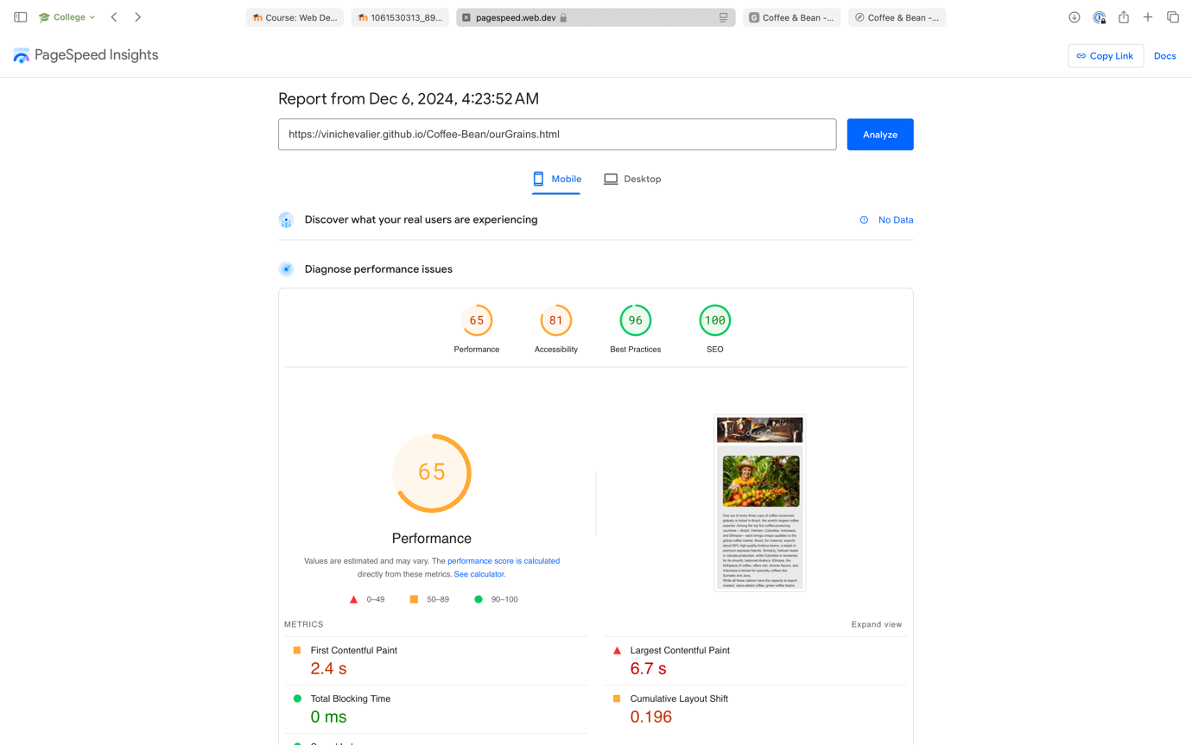

Fig 40. Bean Boutique speed Validation.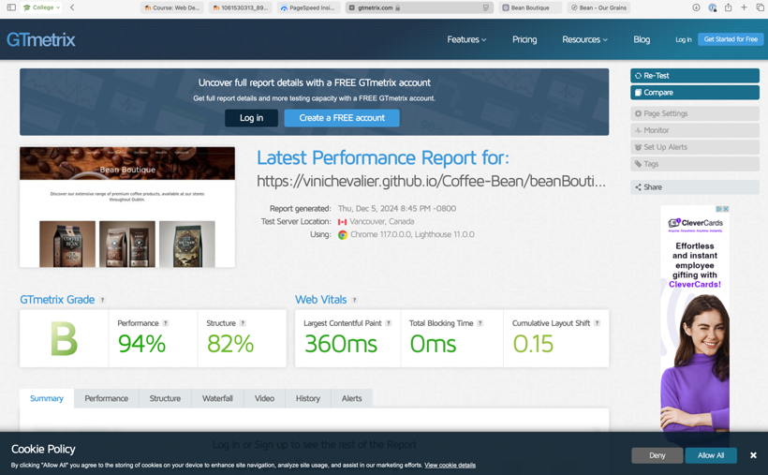

Fig 38. Home (Index) page speed Validation.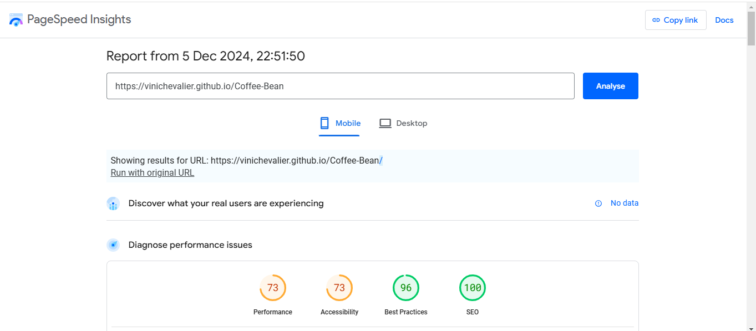

Fig 41. Contact US page speed Validation.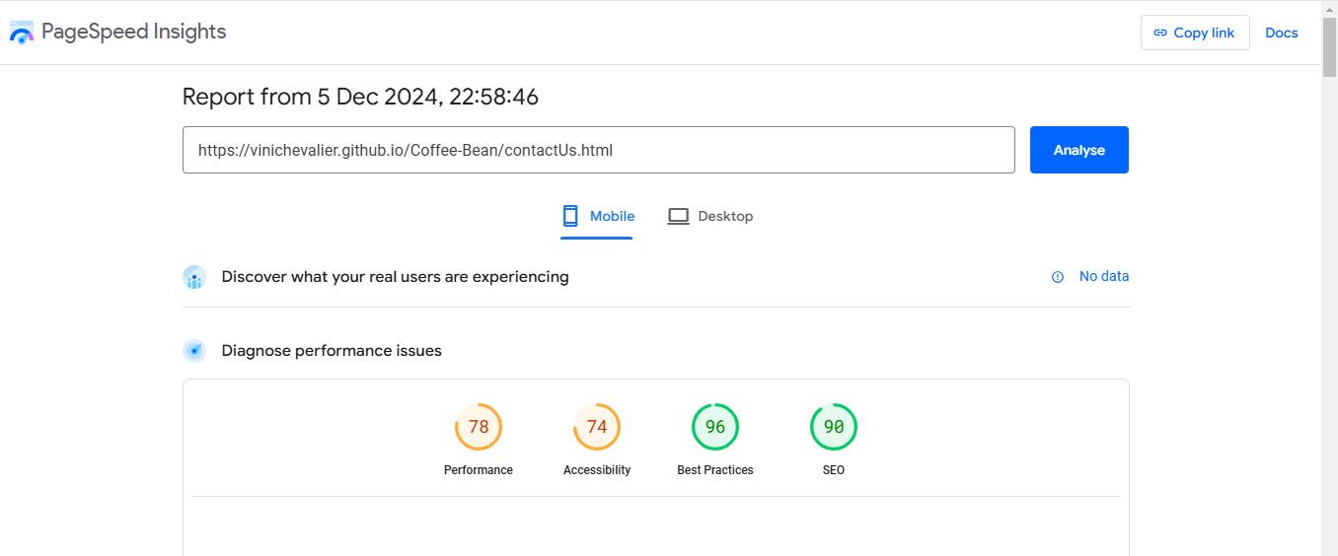

Fig 42. Our Stores speed Validation.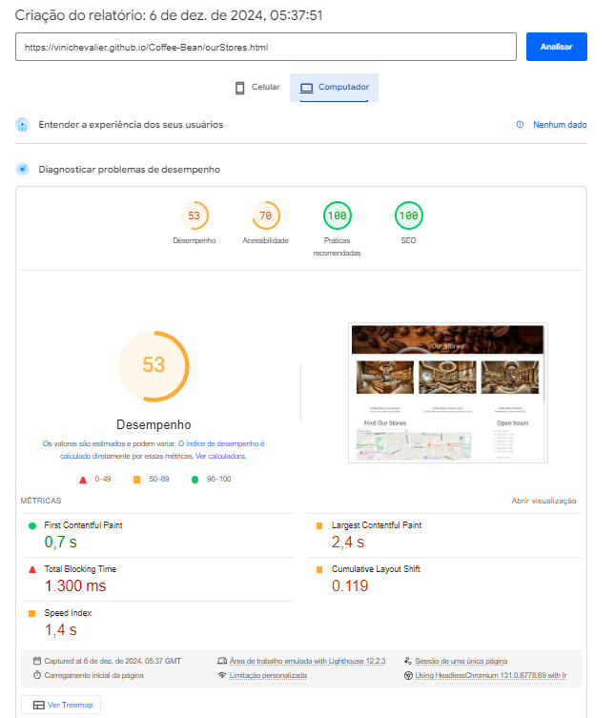

Fig 43. About Us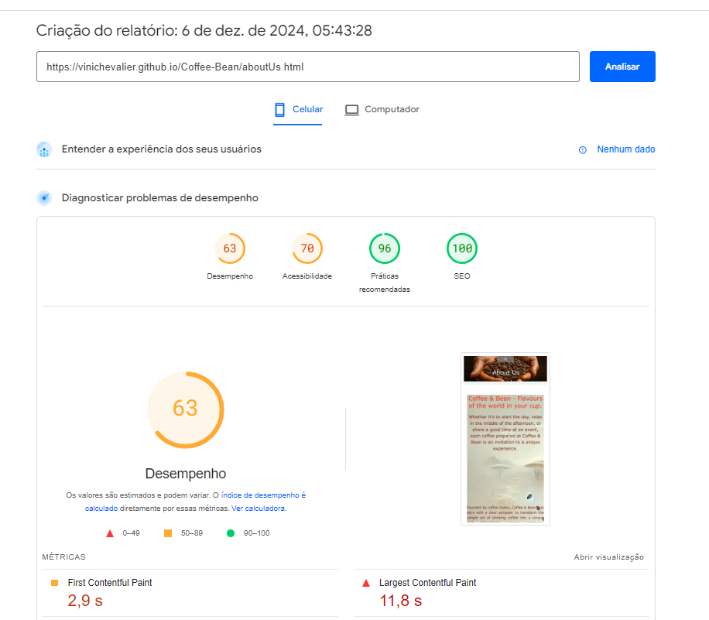

4.5. JavaScript

Offering more quality to the site, the responsiveness can be seen in the texts and images within the tags, but the main point of using JavaScript is the functions that have been implemented. Function ValidateEmail:

The purpose of this JavaScript code is to validate an email address entered by the user in a form and provide feedback based on the validity of the email.

When the user submits the form, the validateForm() function is triggered.

validateEmail() checks if the input is a valid email.They are going to displays "Please enter a valid email address." if the input is invalid or displays "Email is valid." if the input is valid. If invalid, the form is not submitted (return false). If valid, the form submits (return true).

Fig 44. JavaScript Image ValidateEmail.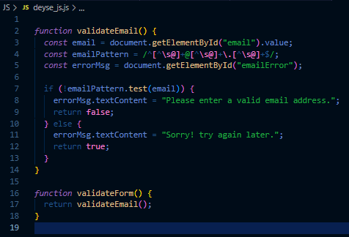

Fig 45. Form Contact Us page

. 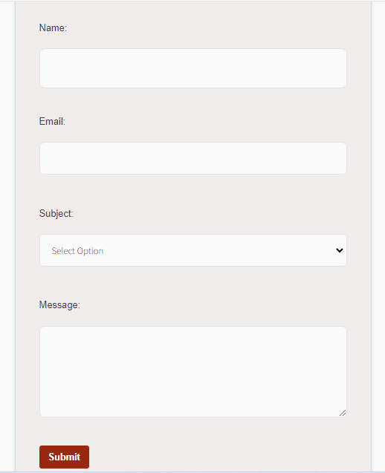

Location selector for shops:

Takes the value from the menu, selects the value and brings up the shop location.

Fig 46. JavaScript statement 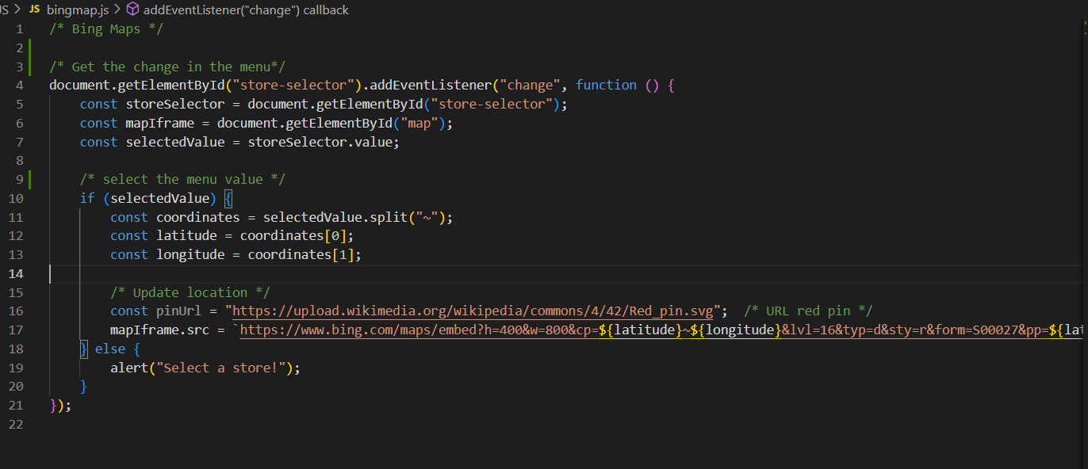

Fig 47. Demonstration of the Bing menu and map.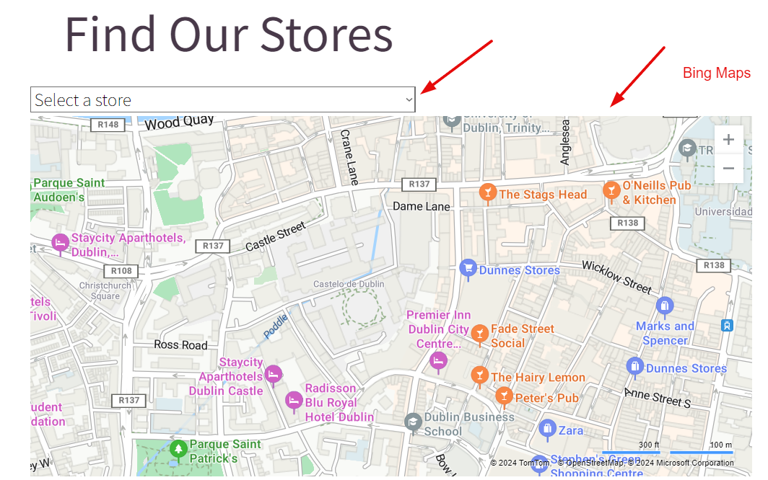

5. Conclusion

In order to complete this website, all the knowledge acquired in the classroom was applied and adjacent research carried out so that it would be complete in terms of the time proposed and within what was requested and designed by the group. Obviously during development there were some meetings where tempers flared, but we would say that this strengthened the union and brought more understanding and synergy. We can emphasise that the creation of the website was a good review of everything applied in the classes taught and a good exercise with a deadline.

7. Reviews

Fig 48. Gisele Gaynor review.  
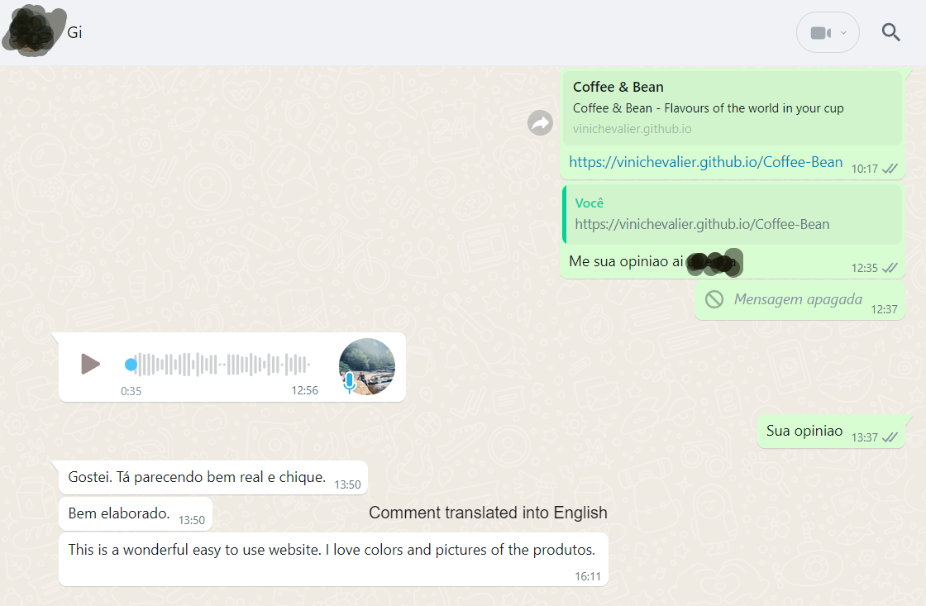

Fig 49. Isabella Macedo review.

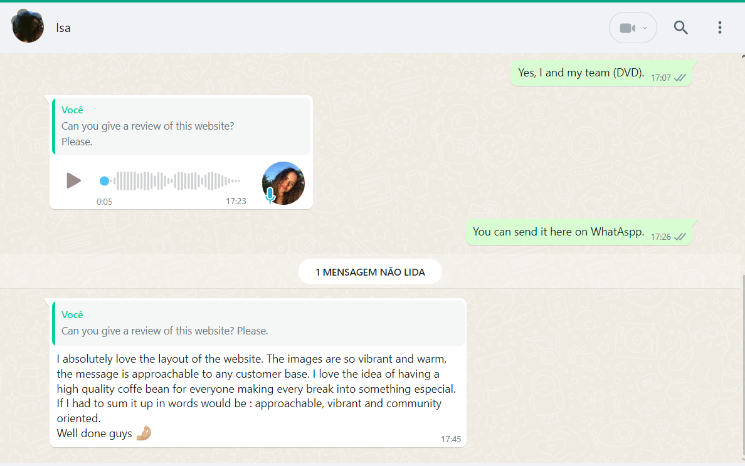

# 7. Reference Images criada by ChatGpt [Online] <https://chatgpt.com>

Video Coffee Platation

# 